

Fall , 2012
Assessment Report Focusing on Two Specific Urban Learners
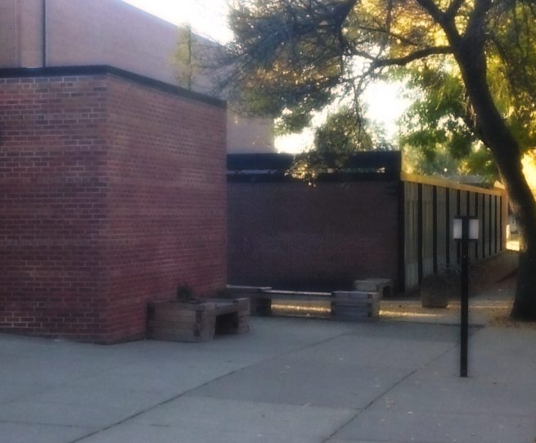
Vance Holmes | Assessment Strategy Report

Assessment Strategy Report

I. Summary of student learning relative to evaluation criteria.

The formative assessment examined for this segment, though not directly concerning the lesson's main text (Seedfolks), has been chosen because it presents the best opportunity to chart my students' growth and my own growth as a teacher. The assessment is a Reading Log -- a weekly homework assignment asking learners to note and reflect on their independent reading. The worksheet requests basic data (text title, total hours read etc.) and asks for responses to four question areas: (1) Describe what you believe is the important message of the story. What is the theme or main idea and how is it important? (2) Write about the conflict. What important issues are being resolved or created in the story? Describe clearly. (3) What personal connections can you make to the story? Explain your connections to the characters, setting, plot, theme, etc. (4) Describe the mood and tone of the story. How does the author make you feel when reading the story and why? What are the author's feelings toward the object, characters, conflict?

The standards/objectives have been established as follows:

• I can read closely to determine what a text says, implicitly and explicitly.
6.4.1.1, 6.5.1.1, 6.5.2.2

• I can support my thinking with evidence from the text.
6.4.1.1

• I can determine how details are used to convey the theme or central idea of a text.
6.4.2.2

• I can develop and organize my writing in a way that is appropriate to the task and audience.
6.7.4.4

• When writing, I can demonstrate my command of the conventions of academic English.
6.11.2.2

40% - All Four Questions Answered
10% - Complete and Clear Sentences Used
10% - Details and Specifics Explained
10% - Meets Reading Hours Requirement
10% - Turned in On-Time
10% - Parent/Guardian Signature
10% - Total Reading Minutes Tallied

Artifacts depict the sixth weekly Reading Log assigned. While some students have failed to even turn in their report, most learners are starting to show growth -- both in their ELA skills and in their commitment to the work and the process!

Of the 25 learners, 12 achieved a score of 100%, 4 scored 80% or better, 2 scored 70%, 7 submitted no work (0 points). This represents a big improvement in overall results from previous weeks. The quality of reflection has also improved. Students had been specifically directed to focus on the use of complete sentences. In that respect, these artifacts show that there has been growth.

Learners continue to struggle with technicalities and organization. A surprising number of them fail to write their name, tally minutes, or answer all questions. Learners also struggle with providing details and clear explanations. A small portion of advanced students are failing to move past surface answers and respond with depth and specificity -- which may be due to the worksheet's simplistic, boxy format.

"Al" (Learner #1) is an African American male. He is a fairly average student but behavior/discipline issues seem to hold him back. Al is quite capable of doing the work. However, he is not connected to the purpose or relevance of class assignments. He struggles with writing in complete sentences, but here shows improvement. Although he only partially responded, and thus scored 70%, Al managed to turn in his work on time and the writing he finished shows that he is starting to care. I was interested to see that he had self-corrected his spelling in two places. Al simply needs encouragement and some insight as to why any of this matters.

"Zeke" (Learner #2) is a Mexican American ELL who struggles with reading and writing, and who also struggles with organization and staying on task. This assessment can build on and deepen Zeke's understanding of reading and writing. In the past, he has been reluctant to engage in the task. This artifact shows that Zeke is now excited to tell about his reading. He is being very expressive. While he has not correctly formatted his report, Zeke has actually managed to address the main questions. I specifically directed Zeke to use the "sentence starter" questions at the bottom of the worksheet. His assignment -- in that context -- was very complete. Despite the technical errors, Zeke achieved a score of 90% because he fulfilled the requirements, in his own way, and showed much improvement. It is important to note that Zeke's Reading Log included a parent signature, which had been missing in previous weeks.

I conclude that both learners are maturing in their view towards the assignment itself. Their growth in attitude has resulted in ELA skill advancement -- or at least in the willingness to share their skills.
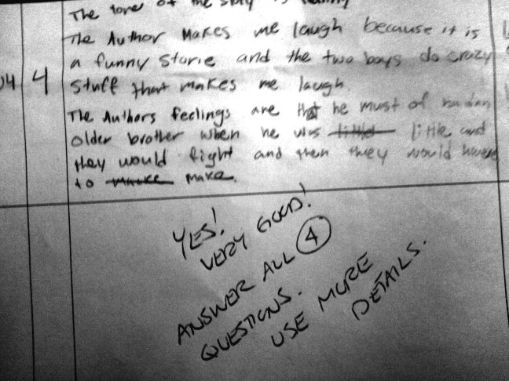

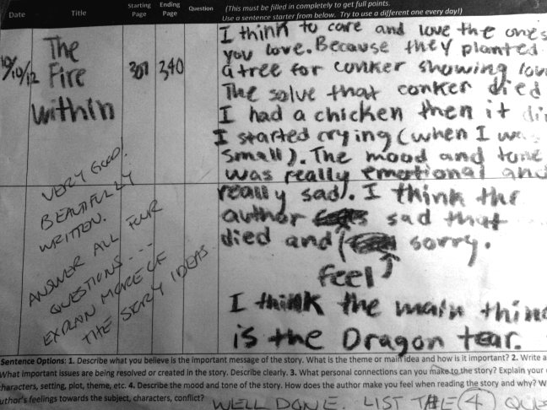

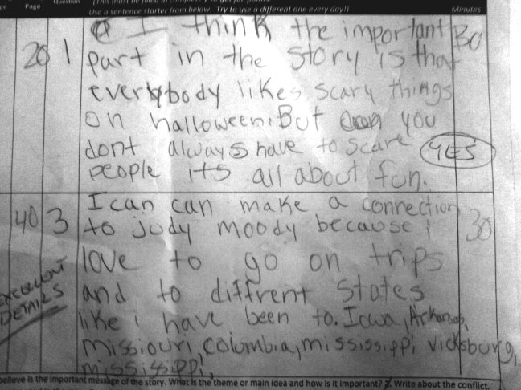

II. Effectiveness of feedback provided to each focus student and address individual student’s needs and learning objectives

Evidence of feedback has been submitted directly on work samples. Al's need for connection was addressed in the feedback through positive words of encouragement. He was also given explicit instructions on format. Zeke's needed to connect writing to self-expression was addressed through comments given as an interested reader. Feedback comments also directly instruct on format. Learners will have an opportunity to improve their work in future weekly assignments.

III. Analysis of instruction for designing next steps

Learners would greatly benefit from a broad review of the worksheet's instructions. Learners would also likely benefit from a newly formatted worksheet. The prompts should be more direct and should include more of the academic language we are learning in class. Student engagement would improve with the use of a “share out” activity, where they are asked to share their thoughts with the whole class. For Al, the next step is to celebrate his achievement, and encourage his impulse to self-assess. The next step for Zeke is to communicate success, and encourage his willingness to express himself freely. Zeke also now requires specialized instructions on conventions.

IV. Demonstrated effectiveness of language supports to promote academic language development for learners with varied language levels

Learners are beginning to use complete sentences. Many learners are starting to incorporate key words and phrases (author, mood, tone) into their written responses. Strategies to promote language development for students with varied language levels appear to be working, but a wider variety of differentiated strategies would increase learner achievement.

