Strategic Instruction Logbook
Urban
Literacy Education

Vance Holmes

Metropolitan State University

EDU-614:
Literacy Education in Urban Schools
Nadine Haley Ph. D.
Fall 2010


PART ONE

Strategies for the Urban Literacy Classroom

Summary: An Anticipation/ Reaction Guide (Readence, Bean, & Baldwin, 2000) consists of several statements related to the text; the statements may or may not be true. Before reading, students indicate whether they agree or disagree with each statement and share their responses through partner, small-group, or whole-group discussion. After reading, students revisit the statements, decide whether their thinking has changed, and mark the statements accordingly. Then we discuss again and students explain any changes in their thinking that may have occurred. We use Anticipation/ Reaction Guides before and after reading informational texts.

Diagram:
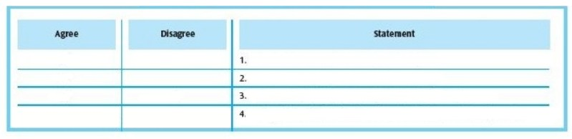

Instructional Connection: Language Arts learners can use an Anticipation/ Reaction Guide to preview what they are about to read and to monitor their thinking while reading. Specifically, this idea helps students activate their prior knowledge, make connections to text, set purposes for reading, and develop more accurate understandings of informational text.

Explain the strategy of previewing and demonstrate by using an Anticipation/ Reaction Guide created prior to the lesson. The Guide should contain 3 to 5 statements that relate to the text. The statements may be facts or statements that are not accurate. Read the first statement in the Anticipation/ Reaction Guide and think aloud about why you might agree or disagree with it. Put a check mark under the Agree or Disagree column at the start of the statement. Guide students to work with partners to read and respond to the next two statements, marking either Agree or Disagree, and discussing their reasoning. Invite students to practice by working on their own to respond to the remaining statements. Introduce the text and read aloud the section of the text to which the statements relate. Encourage students to reflect on what they have learned about previewing and how they can use Anticipation/ Reaction Guides in other content areas.
Summary: The Bio-Pyramid (Macon, 1991) is a summary format for a person’s life that requires particular information and a specific number of words per line. It involves a graphic organizer that appears as a pyramid. In addition to helping students learn how to summarize, the Bio-Pyramid helps them monitor and make connections to the text they are reading.

Diagram:
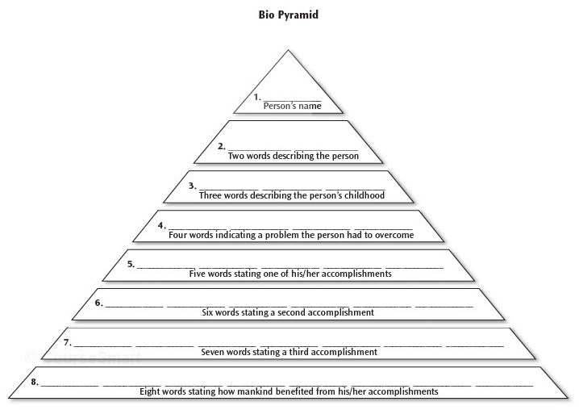

Instructional Connection: Explain summarizing to Language Arts learners as a comprehension strategy that involves extracting essential information from text. Then describe how Bio-Pyramids work, noting that there are 8 lines and that each can accommodate only a certain number of words. Then explain that what we write on each line needs to accommodate the description that appears below the line. Finally, distribute copies of the graphic organizer. Begin to demonstrate by distributing a short biography to the students. Introduce the text. Read the biography aloud to the students and briefly discuss the person’s life. Then think aloud as you complete the first 2 lines of the Bio- Pyramid. For example, if you were creating a Bio-Pyramid about Dr. Martin Luther King, Jr., you might say, “I see that the first line requires the person’s name. It provides only one space, so I will write ‘King.’ The second line asks for two words describing the person, so I will write educated’ and ‘ dedicated,’ because Dr. King was well educated and very dedicated to the Civil Rights Movement.” Guide the students to work with partners as they complete lines 3, 4, and 5 of the Bio-Pyramid. Encourage several partners to share their lines with the class. Then complete lines 3, 4, and 5 on the Bio- Pyramid you began about Dr. King. Have students to practice on their own to complete lines 6, 7, and 8. Encourage students to reflect on how well they can summarize and how they can use Bio-Pyramids in other content areas.
Summary: Readers can use the Bookmark Technique (McLaughlin & Allen, 2002) to help monitor their comprehension while reading and make evaluative judgments about aspects of the text. Bookmark Technique helps students focus on what they are reading and develop at least four points of information to contribute to class discussion. This technique can be used with narrative and expository text, and it works well with both in- class reading and homework assignments.

Diagram:
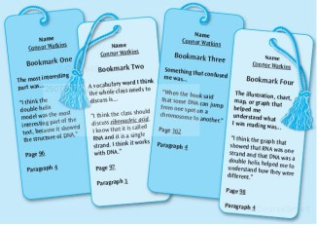

Instructional Connection: Explain to Language Arts learners that monitoring / clarifying is a reading comprehension strategy that involves constantly asking ourselves,“ Does this make sense?”, and adapting strategic processes to make the message clear. Begin by distributing the four Bookmarks. Introduce the text and explain what monitoring is and how the Bookmark Technique can help us monitor our reading. Explain the four book-marks, noting the information required for each:

- Bookmark 1: What was the most important part? Why?
- Bookmark 2: Which word should the class should discuss? Predicted meaning?
- Bookmark 3: What was confusing in this text? Why?
- Bookmark 4: Which illustration helped you to understand what you read? Why?

There is a place for students to include page and paragraph numbers on all Bookmarks. Providing page and paragraph numbers helps the class to locate the information during discussion. Demonstrate by reading a short text to the students. Think aloud as you complete the first Book-mark. For example, if you are using the Bookmarks for a play, you might say: “I think the protagonists’ final speech was the most important part of the text, because it showed his true character.” Guide students to work with a partner to complete Bookmark 2 and 3. Discuss their vocabulary choices. Revisit the text to locate the words and assess whether the students’ thoughts about the words’ meanings are appropriate in the contexts. If needed, use a dictionary to clarify the meanings. Ask students to practice on their own to complete the fourth Bookmark. Discuss their choices. Invite students to reflect on what they know about monitoring and how they can use the Bookmark Technique in other aspects of Language Arts.
Summary: Coding the Text (Harvey & Goudvis, 2000) was developed to help us actively engage in reading by make connections. During reading, we use small sticky notes to indicate the points in the text where we are able to make text– self, text– text, and text– world (others) connections. We use a code for each type of connection (T- S, T- T, and T- W, respectively) and include a few words to describe each connection. We can use Coding the Text while reading narrative and informational text.

Diagram:
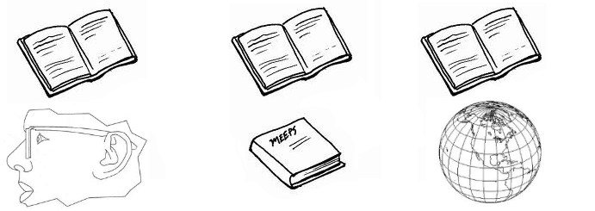

Instructional Connection: Explain to Language Arts learners that making connections is a reading comprehension strategy in which students activate their prior knowledge and make a variety of connections or associations to the text they are reading. Next, clarify that coding provides a way to make connections while reading. Explain that we use coding to mark different points in our reading where we are able to make text–self, text– text, or text–world connections. We write the code for a type of connection —T-S, T-T, or T-W— and a brief description of the connection on a small sticky note. Then we stick the note in the section of the text where we are able to make the connection. Demonstrate by showing students how to label the different kinds of connections on sticky notes. Then read aloud a section of text and pause when you are able to make a connection. Think aloud about which kind of connection you are able to make. Code the sticky note, write a brief description, and stick it next to the section of text where you were able to make the connection. Continue to read the section of text aloud, code your connections and discuss the text and connections. As students read a new section of text, guide them to work in pairs, and guide them to make text–self, text–text, or text–world connections. Ask Language Arts students to code the type of connections and brief descriptions on the sticky notes. Then guide them to insert the sticky notes at the correct points in the text. Discuss the text and the students’ connections. Invite learners to practice on their own by continuing to read another segment and Coding the Text. Discuss the text and connections students made. Encourage students to reflect on how Coding the Text helps us to make connections while we are reading.

Summary: The Concept of Definition Map (Schwartz & Raphael, 1985) is designed to help students construct meaning by making connections between their prior knowledge and new topics. It provides information such as a definition, a description, and examples. This graphic may be used before, during, and after reading. When the map is completed, the class should create a Concept of Definition Map Summary. Creating a summary based on the Concept of Definition Map provides students with the opportunity to use the important information. In the process, students can learn that the important information includes the components of the Map: the definition, description, examples, and comparison.

Diagram:
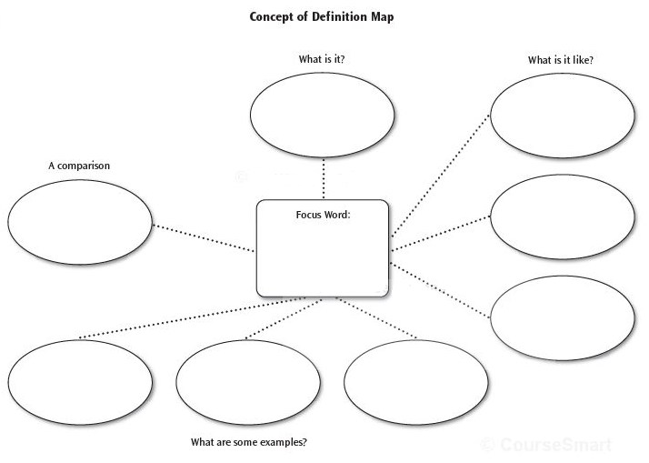

Instructional Connection: Explain to Language Arts students that vocabulary helps us to understand what we read and that the Concept of Definition Map is a graphic organizer that can help us to learn vocabulary. To demonstrate, use a Think-Aloud and a graphic organizer. Select or ask students to select a focus word to be explored. Write the focus word in the oval in the center of the Map. Think aloud to determine the broad category that best describes the word. Write the response in the “What is it?” box. Return to the focus word. Guide students to work with partners to determine responses to the next question on the Concept of Definition Map: What’s it like? Discuss the responses with the students and choose three to include on the map. Return to the focus word. Continue this process with the next question on the map: What are some examples? Return to the focus word. Then discuss possible comparisons for the focus word. Have students practice. Encourage them to read a related text and revisit and revise the Concept of Definition Map as necessary. Then invite the students to use the map to write Concept of Definition Map Summaries. Discuss the summaries. Invite the Language Arts learners to reflect on how Concept of Definition Maps help us to understand words and summarize our thinking. Discuss how we can use these maps in other content areas.
Summary: The Discussion Web (Alvermann, 1991) provides students with a structure to discuss and evaluate given texts. To complete the Web, students investigate both sides of an issue and think critically about a topic with varying points of view. The Discussion Web begins with a question and ends when students come to consensus about the issue. Used with informational text, this technique is designed to spark discussion and debate in all content areas.

Diagram:

Instructional Connection: Explain the strategy to Language Arts students by first selecting a text that provides information about two perspectives on a topic. Share the text with the students. Explain evaluating as a reading comprehension strategy that involves making judgments while reading. Then explain how Discussion Webs focus on questions or statements that have pro and con perspectives and how pairs and ultimately the whole class come to consensus on such issues. Demonstrate the strategy. Think aloud about the topic of the text and a question that might be raised that would require readers to investigate pro and con perspectives. Introduce each of the related texts and invite the students to take a few minutes to read the information. Continue demonstrating by writing the brainstormed question on the graphic organizer. Then take one fact from each perspective and write it in either the Pro (yes) or Con (no) column. Guide students by asking them to work with a partner and add two more facts to each column. Dis-cuss the information they add to the graphic. Have students practice. Ask them to continue working with partners until they have exhausted the facts they would like to include. Then invite them to discuss the information they have compiled and come to an agreement on their position about the topic. Invite the partners to share their positions with the class and then engage in class discussion until consensus is reached. Record the Language Arts learners’ perspectives on the graphic organizer. Finally, ask students to provide a rationale and record that on the graphic organizer. Invite students to reflect on evaluating and how to use the Discussion Web in other content areas.

Summary: Evaluative questioning (Ciardiello, 199) provides a format for us to express ideas and to defend, judge, or justify our thinking. When using this approach, students work in small groups, read text, and generate and respond to evaluative questions. We can use Evaluative Questioning after reading, but we can also use it before and during the reading of narrative and informational text.

Diagram:
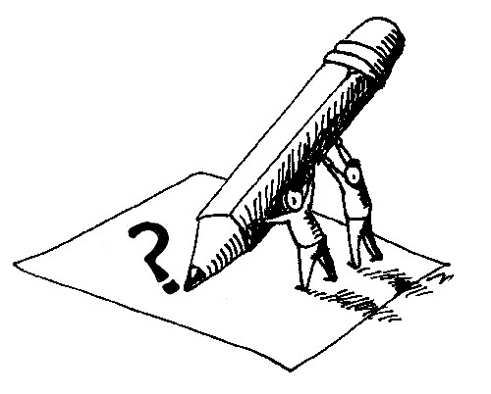

Instructional Connection: Explain evaluating to Language Arts students as a reading comprehension strategy that involves making judgments while reading. Then explain that Evaluative Questioning involves developing ideas and defending or justifying our thinking. Begin to demonstrate by reading a short text, and creating an evaluative question. Continue the demonstration by responding to the question you raised. Defend your response. Discuss Evaluative Questioning with the students. Guide students through the process. Introduce a short text and read it aloud. Before reading, remind the students that they will be generating evaluative questions. After reading, guide students to work in pairs to generate and respond to evaluative questions. Encourage students to generate and respond to at least two evaluative questions. Invite students to practice by reading a short text on their own and generating two evaluative questions. Then ask them to share their questions with their partners, who will respond to them. Reverse the process, so that both students have opportunities to generate and respond to evaluative questions. Discuss Evaluative Questioning with the students. Encourage students to reflect on how Evaluative Questioning helps us to understand text. Then ask students how they might use Evaluative Questioning in other situations or school subjects.
Summary: "I Wonder . . .” Statements (Harvey & Goudvis, 2000) are designed to encourage students to generate questions and to provide a model for active thinking during the reading process. These statements can be used with either narrative or informational text, before, during, and after reading. “I Wonder . . .” Statements can be shared orally, through sketching, or in writing. This strategy employs “I Wonder . . .” Bookmarks that are created during reading.

Diagram:
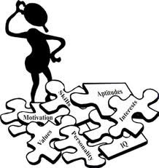

Instructional Connection: Explain self-questioning to Language Arts students as a reading comprehension strategy in which we generate questions to guide thinking. Then explain that we can use “I Wonder . . .” Statements to help us engage in active thinking and generate questions while reading. To demonstrate the strategy, think aloud about the text and the prior knowledge you have about the topic. Introduce the text and create “I Wonder . . .” Statements about the title, both orally and in writing. Read a segment of the text aloud and think aloud about whether your “I Wonder . . .” Statements were confirmed or disconfirmed. Guide the students to work with partners to create “I Wonder . . .” Statements. Ask selected students to share their “wonders.” Ask Language Arts learners to listen to determine whether their statements are confirmed or disconfirmed as you read another segment of text, and then discuss results. Have students practice on their own to create “ I Wonder . . .” Statements in writing. Briefly discuss the students’ wonders and then read another segment of text. Encourage the students to listen to determine whether their statements are confirmed or disconfirmed. Discuss this when you have finished reading the segment. Continue this process until you have finished reading the text. Encourage students to reflect on what they have learned about “I Wonder . . .” Statements and how they help us to engage in self-questioning while reading.
Summary: The KWL is a teaching idea that supports multiple reading comprehension strategies, including self- questioning, monitoring, and summarizing. In the traditional form of KWL, developed by Donna Ogle in 1986, readers ask themselves, “What do I know?”, “What do I want to know?”, and “What have I learned?” In 1995, Sippola suggested that we add a fourth column to the KWL to create the KWLS. The fourth column accommodates the question, “What do I still want to know?” The final column of the KWLS encourages students to examine whether they have found answers to all of the questions they raised in response to “What do I need to know?” If students have not found responses to all of the questions, they move the unanswered questions to the fourth column and continue to research.

Diagram:

Instructional Connection: Explain the reading strategy to Language Arts learners. Focus on the four steps involved in the KWLS: What I Know, What I Want to Know, and What I Learned, and What I Still Want to Know. Begin to demonstrate by introducing the topic and a short text. Share the KWLS graphic organizer with students and think aloud as you brainstorm what you know in the K column. Then move to the W column and list what you want to know. Discuss what you wrote -- then read the text. Record what you learned in the L column. Discuss what you learned. Revisit the K column to determine if what you knew was verified in the text and the W column to ensure that all of your questions were answered. Include any remaining questions from the W column and any new questions about the topic in the S column of the KWLS. Find responses to the questions in the S column. When the KWLS is complete, summarize the information on the chart. Introduce a new text and guide students to work with a partner as each completes the process. Invite students to practice on their own to complete a KWLS chart about another short text. Monitor as they complete each step. Finally, have students share an oral summary of what they learned with a partner. Invite students to reflect on how the KWLS helps us comprehend by providing opportunities to self-question, monitor, and summarize text.
Summary: Mind and Alternative Mind Portraits (McLaughlin, 2001) is a strategy designed to help readers examine a topic from two viewpoints. This technique helps us to evaluate the perspectives that exist within a text. Mind and Alternative Mind Portraits, which are used with informational text, are usually completed after reading. Other versions include Narratives and Alternative Narratives, Photographs and Alternative Photographs, and Videos and Alternative Videos.

Diagram:
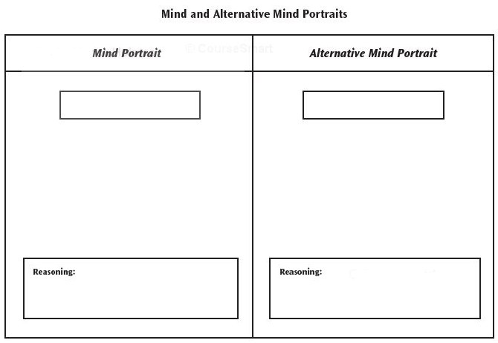

Instructional Connection: Discuss evaluating with Language Arts learners as a reading comprehension strategy that involves making judgments while reading. Then explain how Mind and Alternative Mind Portraits (MAMP) represent two different perspectives. Introduce the text, noting that it contains multiple perspectives, and share the graphic organizer. Use a think-aloud and a read-aloud to demonstrate MAMP. Read the text and choose the two perspectives you will represent. Think aloud as you label the Mind Portrait on the graphic organizer. Inside the Mind Portrait, write or sketch ideas and experiences that describe the perspective. Next, label the Alternative Mind Portrait and think aloud as you write or sketch ideas inside that portrait. Think aloud as you contrast the Mind and Alternative Mind Portraits, noting which perspective is more predominant. Guide students by inviting them to work with partners to begin Mind and Alternative Mind Portraits about another topic. Distribute copies of a short text in which multiple perspectives are represented. Introduce the text and read it aloud. After you have finished reading, encourage students to select two different perspectives on the topic and label the Portraits. Then invite the partners to discuss both perspectives and add two ideas each to the Mind Portrait and Alternative Mind Portraits. Invite the students to discuss their Portraits and share their reasoning. Encourage students to practice on their own to complete the Mind and Alternative Mind Portraits they began with their partners. After the graphic organizers are complete, encourage students to share their reasoning. Ask students to reflect on what they know about evaluating and how they can use Mind and Alternative Mind Portraits to help them evaluate as they read text in the content areas.
Summary: In Paired Questioning (Vaughn & Estes, 1986), students engage in actively generating questions during reading. The strategy entails students taking turns in generating text-related questions and responding to them. When the students have finished generating and responding to questions while reading segments of the text, one partner summarizes the important ideas in the text and the other agrees or disagrees and justifies his or her thinking.

Diagram:
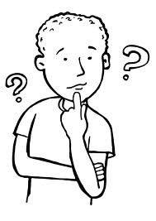

Instructional Connection: Explain to Language Arts students that self-questioning is a reading comprehension strategy in which we generate questions to guide thinking. Then explain that Paired Questioning involves students taking turns in generating text- related questions and responding to them. When the students have finished generating and responding to questions while reading segments of the text, one partner summarizes the important ideas in the text and the other agrees or disagrees and justifies his or her thinking. To demonstrate, arrange in advance to have a student volunteer to be your partner. Introduce the text and demonstrate how you and your partner read the title or subtitle of a section of text, set the text aside, and then respond to the questions each of you generate. Remind students that asking questions about the title or subtitle helps readers set purposes for reading. Repeat this process, reading a section of text instead of the title or subtitle. After you and your partner have responded to the questions, discuss how generating questions as we read helps us to understand the text. Guide Language Arts students to work with a partner and a new section of text to engage in Paired Questioning, first with a subtitle and then with a section of text. Encourage discussion. Have students practice. Invite students to finish reading the text by engaging in Paired Questioning. Stop periodically to discuss the text and the questions that have been raised. When the students have finished reading the text, invite one partner to share the important ideas in the text with the other. Then encourage the other partner to agree or disagree and justify his response. Invite students to reflect on Paired Questioning and how it can help us understand text.
Summary: Paired summarizing (Vaughn & Estes, 1986) provides a format for two students to work together to express their understandings and summarize narrative or informational text. After a text is selected and introduced, each student reads a segment and writes a summary of what was read. Then the paired students read each other’s summaries and summarize them. Next, students compare and contrast their summaries and share their ideas with a small group or the whole class. We engage in Paired Summarizing after reading.

Diagram:
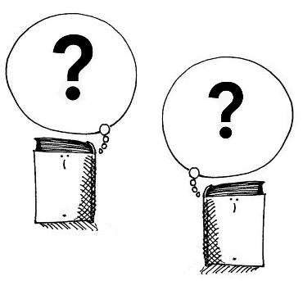

Instructional Connection: First, explain to Language Arts students that summarizing is a reading strategy that involves extracting essential information from text. Then explain that when we engage in Paired Summarizing, we have multiple opportunities to work with a partner to extract important information from text, determine what we understand, and generate questions we may have. Before you demonstrate, arrange to have a student engage in Paired Summarizing with you. Think aloud as you follow each step in the process. To begin, you and your partner read a short text and write a summary of it. You may refer to the article, but you may not have the article in front of you while you are writing. When you finish writing, exchange summaries with your partner. Read that summary and write a summary of it. Then compare and contrast the summaries you wrote with those of your partner. Discuss what you do and do not understand. Create and respond to clarifying questions. Invite students to work with a partner and guide them as they engage in Paired Questioning. Provide a short Language Arts text they can read and summarize. Then observe as they exchange summaries and write summaries based on those they read. Encourage students to focus on what they understand and what questions they have. Guide them to discuss their summaries and questions in small groups. Contribute as requested. Repeat the process with another short text. Discuss Paired Summarizing with the students. Encourage students to practice with partners to engage in Paired Summarizing. Invite students to reflect on how Paired Summarizing helps us understand text.
Summary: Partner Reading (McLaughlin & Allen, 2002) promotes strategic reading, while providing a structure for reading interactively with a partner. A popular alternative to round-robin reading, this technique is used when two students read a text or section of a text together. The partners generally take turns reading, but this approach differs from the traditional partner or buddy reading in that it provides a particular pattern to help both students stay focused, whether they are the reader or the listener.

Diagram:
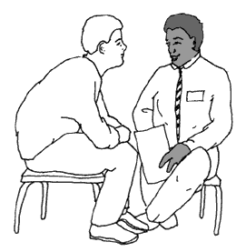

Instructional Connection: The following is a list of possible patterns in which Language Arts students can engage while partner reading:

- Read– Pause– Question: One student reads, the pair pauses, and the student that read asks the other student a question about the text.

- Read– Pause– Make a Connection: One student reads, the pair pauses, and each student makes a connection to self, to text, or to the world.

- Read– Pause– Bookmark: One student reads, the pair pauses, and the students use the Book-mark Technique to mark the following information, so they can share it with the class: Most interesting, Most confusing, A word the whole class needs to know, A chart, map, illustration, or graph that helped the readers understand what they read.

- Read– Pause– Sketch and Share: One student reads, the pair pauses, and each student visualizes and sketches. Then the students share and discuss their sketches.

- Read– Pause– Say Something: One student reads, the pair pauses, and each student “says something” that he found interesting or didn’t know before reading.

- Read– Pause– Summarize: One student reads, the pair pauses, and the other student summarizes the segment that was read.
Summary: The Pre-reading Plan (PreP) is a comprehension strategy that includes activating prior knowledge (What do I already know about this topic?), setting purposes for reading (I will read this text to learn . . .), and predicting and inferring (What can I hypothesize based on what I already know and what I am able to assume from the text?).

Diagram:

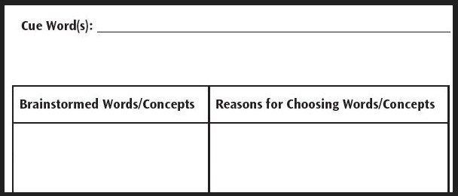

Instructional Connection: Share with Language Arts learners that PreP involves previewing and explain how it works. For example, say: “PreP provides us with an opportunity to brainstorm words or ideas related to a topic and explain why we suggested particular words. After clarifying the words or ideas, we read a related text, revisit the terms, and revise as necessary.” Begin to demonstrate by providing a cue word or idea to stimulate thinking. Then think aloud about which related word comes to mind. Write the word or idea on the board or overhead screen. Then explain why you suggested it. To guide students, invite them to work with partners and brainstorm words or ideas related to the cue word and why they suggested them. Write down their responses. Encourage students to practice by contributing other terms related to the cue word. Next, ask students to explain why they suggested them. Elaborate on the listed words. Then introduce the text and read it aloud. Join the students in reviewing the list of related words and the reasons they were offered. Revise as necessary. Encourage students to reflect on how Pre-reading Plan helps us to activate our background knowledge and predict what might appear in the text.
Summary: Questions into Paragraphs – or QuIP – (McLaughlin, 1987) provides a framework for initiating research, structuring writing, and summarizing. Students choose a topic and develop three related research questions. Then they respond to each question from two sources. When the graphic organizer is complete, students use the information to write a paragraph. We use QuIP before reading (generating questions), during reading (reading the information provided by the two sources), and after reading (writing the summary).

Diagram:
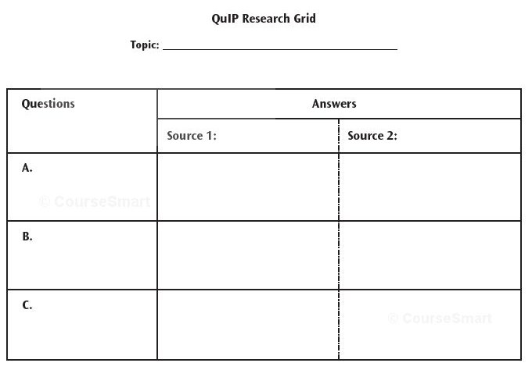

Instructional Connection: First, explain to Language Arts learners that summarizing is a reading strategy that involves extracting essential information from text. Then explain QuIP as a framework for questioning, researching, and summarizing that focuses on developing three questions and responding to them from two different sources. Begin to demonstrate by sharing the graphic organizer and selecting a topic. Then remind students about the importance of generating higher-level questions and develop three research questions. Invite students to work with a partner and guide them as they generate two additional questions. Continue to guide the students as they use bookmarked websites to respond to the three research questions from two sources. Have students complete the graphic organizer and discuss their responses. Encourage students to practice on their own to write a paragraph based on the completed graphic organizers. Invite them to share their completed paragraphs with their partners. Discuss completed QuIPs with the class. Invite students to reflect on how QuIP helps us to summarize and comprehend. Encourage students to think of other ways they can use QuIP.
Summary: When engaging in ReQuest (Manzo, 1969), students actively participate in the discussion of the text. After observing teacher modeling, they practice generating questions at multiple levels. Teachers and students also answer questions. This provides opportunities to engage in the social construction of knowledge and learn the content.

Diagram:
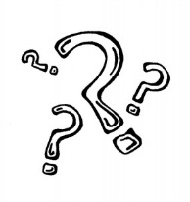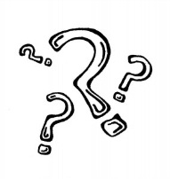

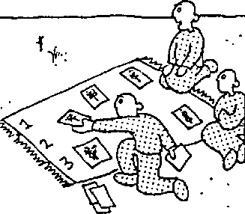

Instructional Connection: Explain self-questioning to Language Arts learners as a reading comprehension strategy in which we generate questions to guide thinking. Focus on ReQuest as a type of reciprocal questioning that involves reading silently, generating questions at multiple levels, predicting, and dis-cussing. Explain that the students and the teacher engage in ReQuest by reading silently and asking one another questions. Demonstrate by introducing the text, and then inviting students to participate in the demonstration. Join them in reading a designated section of text (usually a few paragraphs) silently. Then ask the students to close their books while you ask them questions about the text they read. Comment on the quality of responses. Then close your book and encourage the students to ask you questions. Comment on the quality of the questions. Guide students to engage in ReQuest by silently reading another section of text. Then question the students and encourage them to question you. Have students practice. After students have read an appropriate amount of text, invite them to stop questioning and begin predicting. Invite the students to read the remaining text silently. After they have finished reading the text, facilitate a discussion based on the text and students’ predictions. Encourage students to reflect and think about how ReQuest helps us to use reciprocal questioning and prediction to under-stand text. Discuss other content areas in which students could use ReQuest.
Summary: The Semantic Feature Analysis Chart (Johnson & Pearson, 1984) is a graphic organizer that helps students make predictions about attributes related to specific words, sort by characteristics, and set a purpose for reading or researching.

Diagram:
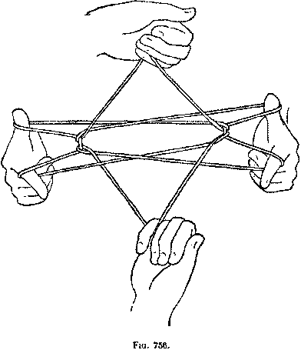

Instructional Connection: Although the Semantic Feature Analysis Chart (SFAC) is often used before and after reading informational text, it can also be adapted for use in Language Arts. Students can use a narrative or story text by replacing the categories with characters’ names and listing attributes that characters may or may not possess. We can also cross-match a variety of genres in the category section with various attributes of those genres in the characteristics section.

Explain to Language Arts students that the SFAC helps us to monitor our thinking and learn about words. Then explain how the chart matches categories and characteristics to provide information. Demonstrate the strategy. Select a topic and some words or categories that relate to that topic. List the words or categories in the far left column of the SFAC. Choose characteristics that relate to one or more of the related words. List those across the top row of the chart. Share the Chart with the students. Make predictions about which categories will have the first characteristic. Place a plus sign (+) in the box if the characteristic fits the category; place a minus sign (-) in the box if the characteristic does not fit the category. Place a question mark (?) in the space provided if you are not sure of the response. Guide students to work with partners in completing the chart, using the symbols you demonstrated. Then read a text that contains information about the categories and characteristics. Discuss the text and the charts with the students. Guide the students to revisit their Semantic Feature Analysis Charts and revise them as necessary. Allow students to practice. Provide another Semantic Feature Analysis Chart and encourage students to complete it. Provide a related text for the students to read. Remind them to revise their charts as necessary based on what they read. Discuss the text and the revised charts. Encourage students to reflect on how Semantic Feature Analysis Charts help us to understand words.
Summary: We use Semantic Maps (Johnson & Pearson, 1984) to activate prior knowledge, introduce content specific vocabulary, and organize information about a topic. When teaching students how to use this map, we choose a focus word, engage students in brainstorming, and create and complete a graphic organizer that features categories and details. We can use completed Semantic Maps to create summaries. Because the design of the Semantic Map depends on students’ responses, the structure of each map is different. We usually use Semantic Maps before and after reading either narrative or informational text.

Diagram:
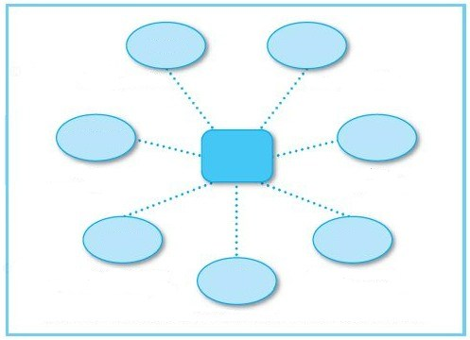

Instructional Connection: Explain to Language Arts students the strategy of previewing and the use of a Semantic Map. Demonstrate by choosing a focus word, writing it on a chart, chalkboard, or computer screen and drawing an oval around it. Then think aloud about what word comes to mind when you read the focus word. Write that word on a different section of the board or computer screen where you will also list students’ responses. Guide students to work with a partner and think about what word comes to mind when they read the focus word. Next, read the focus word and the list of responses. Think aloud about one category that you think emerges from the responses and draw a line from the focus word oval to a satellite oval and write the category within that oval. Underneath the oval, write the words from the list of responses that support that category.
Invite students to practice on their own to determine other categories and suggest which words should be listed beneath it. Add the students’ suggestions to the Semantic Map and continue this process until all of the words on the list of responses on the separate board have been used. Discuss the completed map and show students how the information on the map can be used to create a summary about the focus word. Then introduce the text, read it aloud, and discuss how the focus word relates to it. After the discussion, revisit the map to ensure it provides full and accurate information about the focus word. Revise as necessary. Use the completed map to summarize the topic. Encourage students to reflect on what they have learned about previewing and activating their background knowledge before reading.
Summary: The Semantic Question Map (McLaughlin, 2003) is a variation on the Semantic Map, but its general design is fixed. The focus word is placed in an oval, and then several questions about it are raised. The questions, which may be provided by the teacher or generated by the students, are placed inside the ovals that extend from the oval containing the focus word. We use Semantic Question Maps when we want students to focus on particular aspects of a topic. Rather than leaving the shape of the map to be determined by student responses, we provide the structure, which usually includes three or four questions.

Diagram:
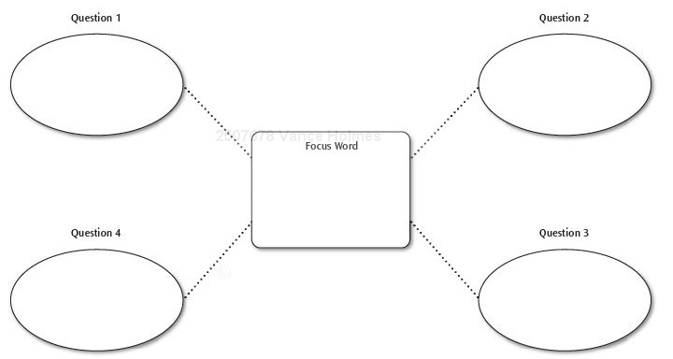

Instructional Connection: Explain to Language Arts students the strategy of Previewing and describe how to use a Semantic Question Map. Explain that Previewing is a comprehension strategy that includes activating background knowledge, setting purposes for reading, and predicting what will come next, based on what we have already read. Completing these Maps involves brainstorming responses to three or four questions about a selected topic. Demonstrate by first choosing a focus word and writing it on a chart, chalkboard, or computer screen. Draw an oval around it and then think aloud about that word. For example, say, “The focus word for this Semantic Question Map is ‘heroes,’ so now I need to think of three or four questions about ‘heroes’ that need to be answered.” Then you might say, “I have thought about the questions and I want them to relate to setting, character, plot and action. Add these questions to the map. Write the questions on the map and use lines to attach the ovals containing the questions to the focus word. Next, offer a response to the first question on the Semantic Question Map. Guide students to work with partners to respond to the next two questions. Then read aloud the section of the text that addresses these topics and discuss it with the students. Make connections to the Semantic Question Map and confirm that the text verifies your responses. Invite students to practice by responding individually to a Semantic Question Map about the next topic of study. Provide the Maps and ask students to write their responses, read the related text, and revise their answers as necessary. Finally, reflect on the completed Semantic Question Maps and the process.
Summary: Sketch to Stretch (Short, Harste, & Burke, 1996) involves using sketching to create, represent, and share personal understandings of text. Sketch to Stretch is usually used in small groups after reading narrative or informational text.

Diagram:

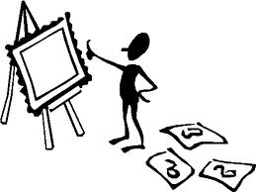

Instructional Connection: Explain summarizing to Language Arts learners as a reading strategy that involves extracting essential information from text and that Sketch to Stretch is a way to represent personal meaning through sketching after reading. Demonstrate by introducing and reading a short selection and thinking about what the text means to you. Next, express your thoughts through sketching. Share your sketch with a few students and ask them what they think it means. Then explain what you think it means. Guide students to work in small groups of 3 to 5. Introduce another short text and either read the text aloud or encourage the students to read it. After reading, ask them to express what the text meant to them through a sketch. Then invite the students to engage in Sketch to Stretch, by sharing their sketches one at a time. After each group member comments on a sketch, the student who created it offers her interpretation. Encourage students to practice by continuing to share and discuss their sketches, until everyone in the group has had a turn. Invite students to reflect on how expressing personal meaning of text through sketching helped them to comprehend. Encourage students to reflect on how they can use Sketch to Stretch in other content areas.
Summary: SQ4R (Robinson, 1946) is a textbook reading study strategy. It also accommodates learning styles by integrating multiple modes of learning. When using this study technique, students survey, question, read, record, recite, and reflect about the text. Textbook study strategies such as Survey, Question, Read, Record, Recite, and Reflect (SQ4R) can also help students when they are reading informational text independently.

Diagram:
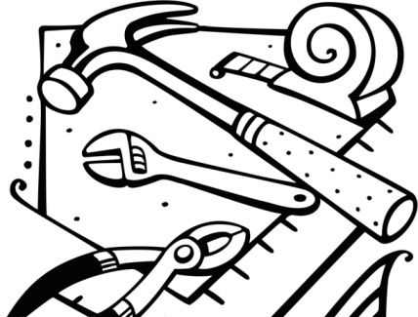

Instructional Connection: Language Arts learners follow 6 steps.

- Step 1: Survey - Preview the text, activate prior knowledge, and make connections. (1) Read the text title, headings and captions that accompany graphics. (2) Preview the introductory and concluding paragraphs. (3) Read the summary. (4) Review text-provided or teacher-created questions.
- Step 2: Question - While you are reading, generate questions to help you think through the text and set purposes for reading. (1) Turn the title, headings, and subheadings into questions. (2) Consider the questions provided in the text or by the teacher.
- Step 3: Read - Use the purpose questions you developed to set purposes for reading. (1) Set times to read and schedule regular breaks. (2) Use your comprehension strategies. (3) Think about possible responses to the questions you raised.
- Step 4: Record - Recording information in writing can help to ingrain the ideas in our memory. (1) Put the information in your own words to ensure understanding. (2) Record information clearly. (3) Record information after reading a section. (4) Use marginal notes as another way to emphasize ideas.
- Step 5: Recite - Saying and listening to information — helps us to remember it. (1) Recite aloud the major concepts of the section using your own words. (2) Ask and answer questions aloud. (3) Study with a partner and orally explain the information to each other.
- Step 6: Reflect - Reflecting helps us to remember information and become more self- aware of our learning. (1) Make connections between new information you have learned and what you already knew. (2) Think about how you can effectively use the new information. (3) Review the information often to retain it.
Summary: Think- Alouds (Davey, 1983) help us to understand what we are reading. For this strategy we select a passage to read aloud to the students. The passage should require some strategic thinking to clarify understandings. We use Think-Alouds to model strategic behaviors and thoughts as we engage in the reading process. That is, we use Think-Alouds to help ourselves focus on strategically thinking our way through text.

Diagram:
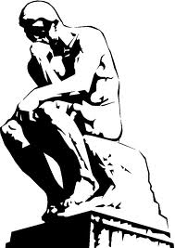

Instructional Connection: Explain the strategy to Language Arts students by first selecting a passage to read aloud. Before reading, demonstrate your connections to the text by thinking aloud about text-self connections and text–text connections. As you read, think aloud to demonstrate other reading comprehension strategies, including monitoring, visualizing, and summarizing. After demonstrating the Think-Aloud several times, guide learners to practice with partners. After sufficient practice, encourage students to try Think-Alouds on their own using text in which they have interest and about which they have background knowledge. Invite Language Arts students to reflect on how thinking aloud helps them to focus on what they are reading. Encourage them to think about how they can use Think-Alouds in other subject areas.
Summary: The Venn Diagram is named for its creator, John Venn, who used it to express thoughts about logic. The diagram, which is represented by two interlocking circles, provides a format for us to note similarities and differences or two perspectives about a topic. The similarities appear in the overlapping sections of the circles; the differences appear in the outer sides of each circle.

Diagram:
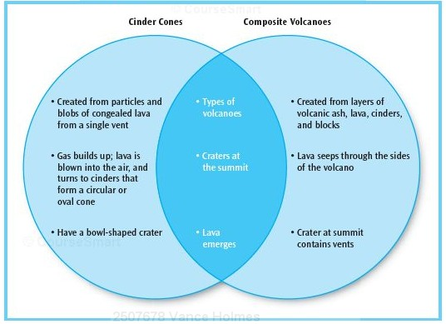

Instructional Connection: Explain to Language Arts learners that evaluating is a comprehension strategy that involves making judgments while reading. Then explain that the Venn Diagram provides us with a for-mat to express the similarities and differences associated with two topics. To demonstrate: read a short text that clearly represents two different perspectives or similarities and differences about a topic. Demonstrate this technique by listing the topics to be compared and contrasted in the spaces provided on the graphic organizer. Then think aloud as you list the common features in the overlapping section of the circles. Note the similarities and differences as they are represented on the graphic organizer. Discuss the completed Venn diagram with the Language Arts students. Guide students to work in pairs to complete Venn Diagrams. Read a short text and provide copies for students. Then ask the students to revisit the text to determine which two topics they might use in their Venn Diagrams. Discuss the topics. Next, invite students to list qualities or characteristics that are common to both topics. Discuss the common qualities or similarities. Encourage students to determine which qualities are unique to each topic and list them in the outer portion of each circle. Discuss the unique qualities (contrasts). Encourage students to practice by reading a short text that presents a topic from two different perspectives and completing a Venn Diagram. Discuss students’ completed diagrams. Invite students to reflect on how Venn Diagrams help us to think through text. Encourage students to reflect on how they can use Venn Diagrams in other content areas and in everyday life to compare and contrast or present two perspectives.
Summary: Vocabulary Bookmarks (McLaughlin, 2003) are designed to motivate students to monitor their understanding and learn new words. Students are to choose a word from assigned class readings and complete a Vocabulary Bookmark. Information on the Bookmark includes: (1) the word, (2) what the student thinks the word means, and (3) the page number on which the student found the word. During the class discussion, students introduce their words, explain what they think the word means, and tell the class where they found the word. Then they read the word in the context in which it appears and discuss the suggested meaning as well as their insights.

Diagram:
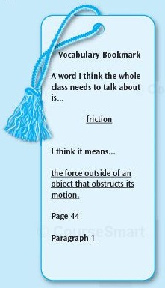

Instructional Connection: Explain to Language Arts students that the Vocabulary Bookmark Technique helps us monitor our understanding of text. Explain the three pieces of information on the Vocabulary Bookmark: (1) the word, (2) what they think the word means, and (3) the page number on which they found the word. Explain that the words are then used during class discussions of the reading. Begin to demonstrate by distributing the blackline (SEE SECTION TWO) for Vocabulary Bookmark Technique. Introduce the text and think aloud as you complete the Vocabulary Bookmark. Demonstrate how to use the page number to find the word in context. Discuss the term with the students, and verify your thinking by checking a dictionary. Guide students to work with partners to find a vocabulary word in the assigned reading that they think the whole class should discuss. Ask students to record the page numbers on which the words appear and what they think each word means, and then discuss their word choices and the related information provided. Have Language Arts students practice the Vocabulary Bookmark Technique by working individually to find words in the next section of the text. After they have completed the Bookmarks, discuss the words and verify their thinking by checking with a dictionary. Invite the class to reflect on what they know about monitoring and how they can use the Vocabulary Bookmark Technique in other aspects of their content area learning.
Summary: The Vocabulary Self-Collection Strategy (Haggard, 1986) was created to encourage students’ interest in vocabulary. Although it is most often used with informational text, this technique can also be used with literature. The VSS is a process that motivates us to learn about words we think are important. When we are reading, we select a word that we would like to learn more about, provide information about it, and nominate it for a place on the class vocabulary list.

Diagram:
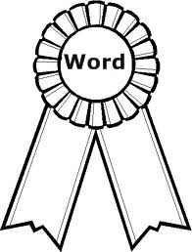

Instructional Connection: Explain to Language Arts students how the VSS works and why we use it. Demonstrate the VSS by reading a selection and choosing a word you would like to learn more about. Share the word with the class by writing it on a board or a chart. Then discuss the word in context, including where it was found in the text, what you think the word means, and where you think it should be placed on the class vocabulary list. Guide students to read a text and engage in VSS. Ask students to select words they would like to learn more about from a previously read text. Invite them to share the words and the following information:

- The word in context
- Where it was found in the text
- What they think the word means
- Why they think the word should be on the class vocabulary list

Accept all nominations and record them on a chart, overhead, or chalkboard. Encourage more practice and discussion about each word. Then narrow the list for study and refine the definitions. Have students record their final word lists and definitions in their vocabulary journals or notebooks. Invite students to reflect on how selecting vocabulary words motivates us to learn and to think about how this process is different from being assigned long lists of vocabulary words to define. Then reflect on how we can use the VSS in other con-tent areas.

PART TWO

Multiple Literacy Methods

Multiple Literacies

- The diverse, urban classroom, challenged by the emergence of multiple literacies, requires educators to carefully consider who is being taught, what will most effectively cultivate learning and how that learning is best assessed. The multicultural classroom demands an unbiased, inclusive curricula and culturally responsive teaching that recognizes, promotes and builds on each student's cultural knowledge base. Culturally diverse materials and strategies of inclusion provide an educational environment where learners of various ethnic, religious and socio-economic backgrounds are empowered to make connections between what they are learning and the world in which they live.
- To be an effective urban educator I must motivate students personally, using culturally relevant, research-based instructional strategies that engage learners and then guide them toward higher-order thinking. Back-mapping lesson plans to Core Standards focuses learning targets on high-order thinking skills. Strategies and standards work best when they are openly shared, carefully explained and related to clearly stated learning targets.
- Urban learners are best taught through encounters with multicultural, multi-literacy experiences and explorations that promote authentic learning of standards-based skills.

Guide Thinking

- Activating background knowledge and setting purposes for reading are essential components of comprehension.
- As a new urban educator, this requires me to remember that each learner brings his or her own unique knowledge base into the classroom.
- Urban learners are best taught when they are able to make connections between what they already know and what they are being taught.

Extend Thinking

- When urban learners are taught comprehension strategies they become active, strategic readers and critical thinkers.
- To be an effective urban educator I must be familiar with a wide, diverse repertoire of effective reading strategies that extend thinking.
- Urban learners are best taught when provided with explicit reading comprehension strategies.

Vocabulary

- Four guidelines for vocabulary instruction (Blachowicz and Fisher 2000). Urban learners should: (1) Be actively engaged in understanding words and related strategies; (2) Personalize vocabulary learning; (3) Be immersed in words; (4) Develop vocabularies through repeated exposures from multiple sources.
- To be an effective urban educator I must feed the need to read and consistently scaffold using the 5-step, Guided Comprehension explicit instruction process: Explain, Demonstrate, Guide, Practice, Reflect.
- Urban learners are best taught when vocabulary instruction is motivational, engaging and involves comprehension.

Organizing

- A key concept on reading instruction for urban learners is organizing though multi-level questions. Ciardiello's four levels of questioning: memory (who? what?), convergent (why? how?), divergent (imagine, suppose) and evaluative (judge, justify).
- To be an effective urban educator I must recognize that the ability to ask questions underpins many aspects of learning.
- Urban learners are best taught to be literate when they know how to organize thinking by generating questions.

Cultural and Linguistic Diversity

- Urban learners construct new meaning by using background knowledge to make sense of the new information they are reading.
- To be an effective urban educator I must learn about my students' lives, appreciate their cultures and provide culturally responsive instruction so urban learners can build bridges between what they already know and what they are learning.
- Urban learners are best taught when I possess and promote positive views about diversity.

Writing

- Key concept on reading instruction for urban learners is that writing, like reading, is a constructivist process. Writers construct meaning when they make connections between prior knowledge and new information and then think through how they can best communicate their message.
- To be an effective urban educator I must engage urban learners in writing which enables them to share knowledge, reveal interests, contemplate connections, and employ critical inquiry.
- Writing promotes critical thinking, problem solving and reading comprehension. Urban learners are best taught when formal and informal writing is integrated into culturally responsive instruction.

Technology

- Reading online, like reading offline, is constructivist in nature. Online reading comprehension is a problem-based, inquiry focused process. Urban learners actively create meaning based on their personal paths to inquiry and discovery.
- To be an effective urban educator I must incorporate new literacies which are the new skills, strategies, and dispositions that are required to successfully identify important questions, locate information, engage in critical evaluation, synthesize information and communicate using emerging technologies.
- Urban learners are best taught when technology is integrated into reading instruction and content area lessons considering the four factors outlined by Richardson (2004) which include: (1) Broad topic (2) Appropriateness (3) Back-up planning (4) Seamless incorporation.

Inquiry

- Inquiry-based learning (IBL) is a product-oriented teaching method. Constructivist in nature, IBL is a strategy in which students ask questions that lead to new understandings. Generally, the process involves five steps: question, investigate, create, discuss and reflect.
- To be an effective urban educator I must incorporate inquiry-based learning (or, Problem Based Learning -- PBL) experiences into classroom activities to motivate and engage urban learners.
- Urban learners are best taught problem-solving through student-centered, inquiry-based strategies which foster creativity, variety and innovation, and promote connections between what students learn and the world in which they live.

Alternative Representations

- Teaching urban learners to represent their thoughts through poetry, music, drama and art broadens their communication possibilities and strengthens their understanding. It also helps to engage their thinking and accommodate their learning styles.

- To be an effective urban educator I must include teaching strategies that integrate the arts understanding that they may provide more meaningful and more creative ways for students to represent their ideas.
- Urban learners are best taught when they are provided opportunities to express their individual thoughts in a variety of ways. Multiple forms of representation celebrate our unique natures and encourage us to share our ideas in the most meaningful ways.

Assessment

- Innovative assessment practices serve to accommodate urban learners' individual styles, relate learning to life experiences, and incorporate educational standards. Particularly valuable are authentic assessments which offer windows into students' minds and insights into their thinking processes.

- To be an effective urban educator I must become an assessment expert, able to efficiently gather information that demonstrates what students know and can do. I must also be able to develop criteria to objectively assess student products and accurately evaluate student growth.

Guided Comprehension

- When using any teaching strategy, teachers should (1) help students to understand why a strategy is useful, and (2) describe explicitly how the strategy should be used. Teacher demonstration, modeling, and follow-up independent practice are critical factors for success. Student discussion following strategy instruction is also helpful. Explain, Demonstrate, Guide, Practice and Reflect

Reading Strategy Objectives

- Activate Prior Knowledge, Analyze Ideas from Text, Build Vocabulary, Identify Main Ideas and Details, Summarize Information, Synthesize Ideas, Make Connections, Identify Author’s Viewpoint and Purpose, Paraphrase Ideas, Synthesize Information, Make Generalizations, Build Vocabulary, Draw Conclusions

The Write Stuff - I

- After reading a selection, students revisit the text to collect samples of writing strategies. In small groups students sort and analyze the samples. As a group they discuss each other’s opinions about the effectiveness of each sample. Questions that help students explore writing strategies: “What strategies did the author use?” “Why do you think the author chose the strategy to communicate ideas about this topic?” “How would the use of this strategy help readers understand the information?”
The Write Stuff - II

- Begin a unit of study by constructing an Attribute Chart for Writer’s Strategies. At the top of the chart, write strategies students will collect during the study. Down the left-hand side of the chart, students write the titles of reading selections. When students locate a sample of a writer’s strategy in an article, they add it to the Attribute Chart. At the end of the unit, ask students to meet in small groups to analyze the data collected on the Attribute chart.
- Read different books on the same topic. Show how various authors use unique approaches to the same topic.
- Compare fiction, non-fiction and poetry on the same topic. Discuss how each genre contributes to student's understandings.
- Read examples of non-fiction writing using a narrative style. Compare to a book on the same topic written in more typical expository style.
- Show various formats used to convey information – alphabetical order, scrapbook style, first person, pop-up, flaps and transparent pages, etc.
- Compare the use of drawings vs. photographs by discussing the effect of each kind of illustration.

Paragraph Shrinking

- Paragraph shrinking is an activity developed as part of the Peer-Assisted Learning Strategies (PALS). The paragraph shrinking strategy allows each student to take turns reading, pausing, and summarizing the main points of each paragraph. Students provide each other with feedback as a way to monitor comprehension.

If I Were the Author

- Students read an informational article. They explore questions about the author’s viewpoint, purpose, and style. After analyzing the text, students share their responses, feedback, and evaluations about the effectiveness of the selection. Invite students to summarize their ideas by completing the sentence, "If I Were the Author I would . . ."
First Lines

- First Lines is a pre-reading comprehension strategy in which students read the beginning sentences from a book and then make predictions about that book. This technique helps students focus their attention on what they can tell from the first lines of a story, play, poem, or other text. As students read the text in its entirety they discuss, revisit and/or revise their original predictions.
Differentiated Instruction

- Give students who need extra help the chance to work with a partner.
- Allow students to use pictures to illustrate when appropriate.
- Adjust the number of words students need to map.
- Provide students with sentences each containing the target word. The sentences should provide enough context clues to enable students to complete a word map.
- Instruct advanced students to refer to the dictionary, encyclopedia or other reference books for help in completing the word map. Ask them to compare their definitions and the dictionary definition.

Music Messages

- Students write a line by line analysis of a song which they feel expresses a powerful message that can change society for the better. They then present their analysis to the class in an oral report.

Satire

- Students consider satire in the news by exploring various sources of "fake news," and then creating their own political satire in the form of a skit, news article, or cartoon.

What is Good Writing?

- Students examine samples of writing and discuss the score it received. They brainstorm what qualities make a good writer and stories.
Alliteration

- Students collect facts about a topic from a variety of reading materials. Using key ideas collected from their research, students write three-word clusters that describe the topic. All words in the cluster start with the same letter. Invite students to use the cluster phrases to write fact sentences or alliteration poems. ("Meandering manatees move gracefully through the warm waters of the river’s run.")
Expert Panel

- After students have researched facts on a topic, they become “Experts” and present the data in a creative way to an audience. The experts participate in a panel discussion. They make a presentation that summarizes facts about the topic. They elicit and respond to questions from the audience.

Genre Matching

- After reading a selection, students classify the text as descriptive, expository, persuasive, narrative, informational, technical, clarification, or expressive. They collect words, phrases, and sentences from the text to support their classification. Students may determine that a selection belongs in more than one category. Focus discussion and instruction on students’ reasoning rather than the choice of category.

Fact or Opinion?

- Read an informational article. Underline fact sentences. Create a "Fact or Opinion" worksheet for students to solve. Write fact and opinion statements using the information in the text. Students identify which statements are fact and which statements are opinion.

