**A Pop Literacies, Urban Middle School Language Arts Unit Learning Plan**

**Vance Holmes**

**Metropolitan State University**

**LAED-450: Teaching Language Arts**

**in Urban and Middle High Schools**

**Dr. Daryl Parks**

**December, 2011**

Powers of Persuasion: Pathos



**Powers of Persuasion: Pathos**

A Pop Literacies, Urban Middle School Language Arts Unit Learning Plan



In this seven-lesson, multimedia, Language Arts unit – eighth grade urban learners encounter the power of persuasive speaking and expand their understanding of the concept of persuasion in advertising. Learners consider that effective speakers use volume, pacing, vocal inflection and word choice appropriate to audience. They evaluate how rhetoric designed for a target audience employs imagery and *transfer* to make appeals to emotion. Through questions concerning cultural perspective, learners also look at ways in which they themselves are a target audience, developing awareness of how the popular mass media maneuvers to persuade them as purchasers of products and consumers buying in to the cultural marketplace of ideas.

While this plan is a discrete, one-week unit,***POP: Pathos*** is envisioned as the second part of a four-part series – not necessarily scheduled back-to-back -- investigating the three appeals identified by Aristotle in classical rhetoric: appeals to reason (logos), to emotion (pathos), and to the speaker’s authority (ethos). These persuasive text/pop media units would ultimately lead to a major final project where teams of learners would collaborate to prepare live multimedia presentations – expressing opinions on a social or cultural issue at play in Chris Crowe’s narrative non-fiction text, *Getting Away with Murder: The True Story of the Emmett Till Case,* or a similar work.

**In this unit, learners will**:

* Review and discover vocabulary associated with persuasive speaking and persuasive advertising techniques;
* Interpret their thoughts about various advertising images, symbols and slogans;
* Write and deliver a targeted ad voice-over using various learned techniques;
* Create a sound recording of a persuasive speech using *Audacity* software;
* Create a full-motion video clip and publish it using Animoto.com webware;
* Present targeted texts and assess why and how student ads are convincing.

**Instructional Strategies**: Lesson Two sequence is from Sullivan’s “Persuasive Speech” lesson – at Poway Schools, Powayusd.com. Lesson Three uses ideas and information from McCarthy’s “Persuasion through Advertising” lesson, located at Scholastic.com.

**Big Idea**: Cultural Perspective

**Essential Questions:**

* What makes a good speaker?
* What makes a persuasive speech?
* For what purposes might an author create a persuasive speech?
* How are images associated with emotions and feelings?
* How are images used to persuade?
* What is perspective?
* What is cultural perspective?
* What cultural perspectives do I identify with?
* How do I deliver a spoken text convincingly?
* What is a target audience?
* What target audiences do I belong to?
* How does intended audience affect word choice?
* What shapes our point of view?
* How do others influence our thinking?

**Lesson Plan Overview**

* Lesson 1 – POP Quiz
  + Web pretest. Review vocal speech techniques -- What makes a good speaker? - volume, pacing and vocal inflection. [What is perspective?]
* Lesson 2 – Commercial Properties
  + What makes a good speech? - word choice. Targeting audience. [How can persuasion skills be used to change perspective?]
* Lesson 3 – Target Audience: Pathos
  + Investigate the concepts of *transfer* and appeals to emotion. [What is cultural perspective?]
* Lesson 4 – The Write Angle
  + Vocabulary Quiz Bowl. Write text, make word choices, for advertisement voice-over. [What cultural perspectives do I share with others?]
* Lesson 5 – Speaking Engagement
  + Deliver and listen to voice-over speeches. [How does my worldview differ from the perspectives of others?]
* Lesson 6 – Power of Pictures
  + Vocabulary Quiz. Create sound file, choose picture files for voice-over and publish video [How do others influence my thinking?]
* Lesson 7 – Commercial Appeal
  + Presentation of final projects / evaluations. [How is my worldview shaped by the way the world views me?]

**Learners**: (based on a class from Patrick Henry High) 22 mixed ability students of widely diverse cultural backgrounds. Class has theoretically had a previous speech unit – *POP: Logos* – and some experience with the basic vocabulary associated with persuasive speaking, the delivery of brief speeches and solo readings, and manipulation of *Audacity* sound recording software and Animoto.com webware.

**Duration:** seven, 60-minute sessions

**Special Resource Requirements**: computer lab, Animoto.com account, *Audacity* software, examples of print and video advertisements from Creativity-Online.com

**Materials – Unit Plan Forms:** Target Audience, Picture–Symbol–Slogan map, Transfer Techniques, Voice-Over rubric, Persuasive Presentation rubricfeedback form, web pretest, web POP Quiz, Vocabulary list for Quiz Bowl review

**Resources/Websites:** Animoto.com; sample adverts from [www.creativity-online.com];

“Persuasive Speech” lesson by April Sullivan [www.powayusd.com/pusdctae/exex/2009-products/Hospitality/ admin\_powayusd\_com\_20090724\_163000LessonPlan6.pdf].

“Persuasion through Advertising” lesson by Tara McCarthy at Scholastic.com [www.scholastic.com/teachers/lesson-plan/pictures-and-slogans-persuade-audience];

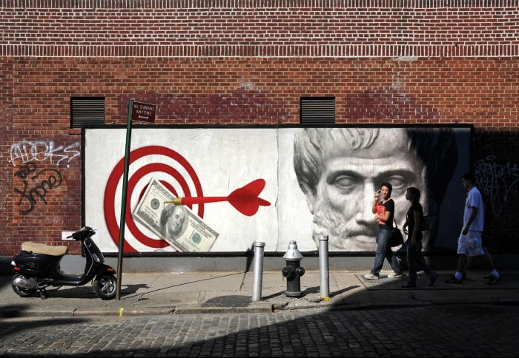

*The three appeals identified by Aristotle in classical rhetoric;*

*appeals to reason (****logos****), to emotion (****pathos****), and to the speaker’s authority (****ethos****).*

**POP: Pathos**  
Core Learning Strategy Map



**Standard:** 8.9.3.3 Delineate and respond to a speaker’s argument, specific claim, and intended audience, evaluating the soundness of the reasoning and relevance and sufficiency of the evidence and identifying when irrelevant evidence is introduced.

**Core Objective:** I can determine a speaker’s target audience to evaluate a speech’s power and persuasiveness.

**Learning Target:** I can identify names of common vocal techniques used by speakers.

**Learning Assessment:** word splash, vocabulary quiz bowl

**Learning Target:** I can evaluate a persuasive spoken text.

**Learning Assessment:** two Voice-Over rubric forms – partner and self-assessment

**Core Assessments:** vocabulary POP Quiz - **20%;**

six completed *Persuasive Presentation Rubric* feedback forms - **30%**

Assessment Description: Just before learners partake in the unit’s final presentations, they will each be randomly assigned the names of six other students whose projects they will evaluate using the Persuasive Presentation rubric feedback form.

**Standard:** 8.9.4.4 Present claims and findings, respect intellectual properties emphasize salient points in a focused, coherent manner with relevant evidence, sound valid reasoning, and well-chosen details; use appropriate eye contact, adequate volume, and clear pronunciation

**Core Objective:** I can present my ideas clearly and convincingly to a target audience.

**Learning Target:** I can author a speech intended for a specific audience.

**Learning Assessment:** written text of advertisement voice-over

**Learning Target:** I can deliver a speech persuasively.

**Learning Assessment:** speech presentation of advertisement text

**Learning Target:** I can record a speech using standard software.

**Learning Assessment:** *Audacity* sound file of voice-over

**Learning Target:** I can create a full motion video using standard webware.

**Learning Assessment:** published Animoto.com video

**Core Assessment:** final presentation of published advertisement projects - **50%**

Assessment Description: Learners will give a brief introduction and present a published 30-second Animoto.com video – for assessment of written text, **\***recorded speech, and multimedia elements.

**Success Opportunity for Urban Learners** – **SOUL Focus**:

Comprehension, Collaboration and Presentation of Knowledge

**\***Based on evaluation of the initial speech presentations, this summative core assessment could be altered so that students would deliver speeches live as their Animoto media file’s music and images play. This would place a greater emphasis on public speaking -- if focus on that skill component is deemed necessary.

**ISTE NETS** (National Educational Technology Standards) addressed:

**Standard 1** - Students demonstrate creative thinking, construct knowledge, and develop innovative products and processes using technology.

**Standard 6** - Students demonstrate a sound understanding of technology concepts, systems, and operations.

**Differentiated Instruction**: This multidimensional, multiliteracy unit dynamically aligns with several of the MDE’s *Speaking Viewing, Listening, Media Literacy* benchmarks for Grade 8 and should be fairly simple to adapt to suit all learners in an urban middle school program. For the final project, advanced learners could alternatively be invited to deconstruct a completed, previously published Animoto design and create new narration for a specific target audience – while differentiation for struggling learners might involve inviting students to work in pairs or shifting project length requirements.



Please note the name and acronym of the new heading listed under standards, representing my thought to include -- along with a state standard – an additional standard that specifically identifies the college and career readiness anchor area for inner-city students: *Success Opportunity for Urban Learners*– ***SOUL Focus****!* This urban learning protocol -- based directly on the Common Core website’s CCR definitions – would be an instructional planning assessment tool and a guide to answering the question: “Why do we need to learn this?” My concept here is to energize the passive, academic CCR language so that urban students are explicitly instructed as to which of the basic, broad areas of life and learning skills are being addressed.

**Lesson Plan 1**  
POP Quiz

Language Arts / Grade 8  **Creator:** Vance Holmes

Lesson Plan 1 of 7 **Create Date:** December, 2011



Objectives:

* Introduce unit on persuasive speaking
* Pretest for vocabulary

Essential Questions:

* What is perspective?

Targets:

* I know the vocal qualities of a good speaker

00 | **Preflection Activity:** Ask learners if they have ever been bored listening to someone make a speech. Discuss examples of boring speeches they've heard. Where was the speech? What audience was being spoken to? Why was the speech boring?

05 | **Prior Knowledge Activity:** Explain that learners will be starting a speech unit that will help them become effective and persuasive speakers. Learners to PC lab to take timed POP Quiz. Return to room when web pretest is finished.

|  |
| --- |
| 20 | **Vocabulary Development:** Use SmartBoard to brainstorm qualities of a good speaker -- look for volume, pacing, vocal inflection, language/word choice. Emphasize qualities as appropriate to purpose and audience. Say, “A persuasive speaker uses volume, pacing, vocal inflection and word choice appropriate to purpose and audience.” |
| 30 | **Skill Lesson - Instruct/Model:** Play any selected sample radio ad clip from www.creativity-online.com. After listening, ask learners to examine the speaker(s) in order to determine qualities of volume, pacing and vocal inflection. Post the three categories. Listen again. Discuss and post learner’s evaluations. Listen to a second clip. Ask for the qualities of the speaker’s voice in terms of volume, pacing and vocal inflection. Listen again. Discuss and post learner’s findings. |
| | **Literacy Activity:** Read Aristotle quote. |
| | **Post Literacy Activity**: |

50 | **Reflection Activity:** Review posting of the unit’s CCR Anchor and two learning targets. Tease that students will be writing, performing, recording and evaluating their own speeches using commercial voice-overs! Exit Slip -- “Think of a particular book, poem, movie, TV show etc. that you strongly identify with. Reflect, briefly explaining how it expresses your perspective.” (Daily quick-writes will be filed in student folders.)

**Independent Study:**

**Materials:** web pretest, selected commercial clips from www.creativity-online.com

**Lesson Plan 2**  
Commercial Properties

Language Arts / Grade 8  **Creator:** Vance Holmes

Lesson Plan 2 of 7 **Create Date:** December, 2011



Objectives:

* Understand Target Audience

Essential Questions:

* How can persuasion skills be used to change perspective?

Targets:

* I know the language qualities of a good speech

00 | **Preflection Activity:** Admit Ticket –“When has someone tried to convince you to do something that you didn‘t want to do? How did they try to convince you?”

05 | **Prior Knowledge Activity:** Students pair and share their Admit Tickets. Use tickets to demonstrate how advertisers are trying to persuade us to buy or try something.

|  |
| --- |
| 15 | **Vocabulary Development:** Discuss criteria of a persuasive speaker (volume, pacing, vocal inflection) and a persuasive text (word choice). Explore why the criteria is important to commercial advertisers (appropriate to audience). Ask learners to define Target Audience. Say, “A Target Audience is a group of people who can be identified by some common characteristic, interest, or need.” |
| 25 | **Skill Lesson - Instruct/Model:** Illustrate the concept of Target Audience by distributing several different types of magazines (Family Circle, XXL, 13 Minutes, Teen, Time, S.I.) Discuss what kinds of products are advertised in each magazine. What are the target audiences? (gender, age, culture, lifestyle) What ways do the advertisers appeal to these different audiences? (Students should notice that the pictures used are different, the language is different.) Collect materials. Explain that for today’s independent research students are to choose a TV or magazine ad and determine the Target Audience. Have learners locate Target Audience forms in folder. Post to SmartBoard. Play any selected sample advert from www.creativity-online.com. Post and ask form questions. (Product, Slogan, Describe visual images, Who is the target audience and how do you know this?) Use learner’s answers to model completing the form. |
| 40 | **Literacy Activity:** Focus on one of the magazine ads. Invite learners to use their worksheet to record information. Evaluate print ad along with students. |
| | **Post Literacy Activity**: Time permitting, have learners pair and evaluate a print ad. |

50 | **Reflection Activity:** Exit Slip -- “Describe a time when you tried to convince a friend or family member to do something. Did you persuade them?”

**Independent Study:** Target Audience research

**Materials:** selected clips from www.creativity-online.com**,** Target Audience forms

**Lesson Plan 3**  
Target Audience: Pathos

Language Arts / Grade 8  **Creator:** Vance Holmes

Lesson Plan 3 of 7 **Create Date:** December, 2011



Objectives:

* Define and explore *pathos*

Essential Questions:

* What is cultural perspective?

Targets:

* I recognize images as appeals to emotion

00 | **Preflection Activity:** Admit Ticket – “If you were a member of a target audience, how would you be described?”

05 | **Prior Knowledge Activity:** Pair and share Target Audience research. Conduct a class discussion about their findings. What makes the advertisements attractive and convincing? Ask students for examples and allow them to discuss the difference between the images and slogans that they found. What do they symbolize? Who is being targeted?

|  |
| --- |
| 15 | **Vocabulary Development:** During the class discussion, post three columns on the SmartBoard and label them: Pictures, Symbols, and Slogans. Now based on the class discussion, list examples of what students qualify each as a picture, symbol, or slogan and write various examples in each column. |
| 25 | **Skill Lesson - Instruct/Model:** Distribute the Pictures-Symbols-Slogans map and accompanying Transfer Techniques form to students. Step 1: Post and direct attention to the PSS map. Ask students to quickly brainstorm what comes to mind when they see the symbol or read the catchphrase in the first column. Write students' responses in the second column. Students will write their responses on their own worksheet. |
| 35 | **Literacy Activity:** With the class, discuss what ***transfer*** means in persuasive writing: the appeal to emotions and feelings through pictures or phrases. Post and direct attention to the Transfer form. Model using the Transfer form. Have students remove worksheet from folder and complete outside of class. |
| | **Post Literacy Activity**: |

50 | **Reflection Activity:** Post web browser and navigate to www.creativity-online.com. Have learners choose and listen to one of the radio public service announcements located at the site.

**Independent Study:** Transfer Techniques form

**Materials:** Pictures-Symbols-Slogans map and Transfer form

**Lesson Plan 4**  
The Write Angle

Language Arts / Grade 8  **Creator:** Vance Holmes

Lesson Plan 4 of 7 **Create Date:** December, 2011



Objectives:

* Write persuasive advertisement

Essential Questions:

* What cultural perspectives do I share with others?

Targets:

* I can target language to audience

00 | **Preflection Activity:** Admit Ticket --“What interests, needs, personal problems and social concerns do most teenagers have in common?”

05 | **Prior Knowledge Activity:** Collect Transfer forms. Ask, “What interests, needs, personal problems and social concerns do most teenagers have in common?” Use previous discussion ideas about Target Audiences. Question: “What interests, needs, personal problems and social concerns do teenaged girls have in common? Boys?”

|  |
| --- |
| 10 | **Vocabulary Development:** Divide into teams for a game of **Vocabulary Quiz Bowl**. |
| 20 | **Skill Lesson - Instruct/Model:** Have learners locate the Voice-Over rubric in folder and review it as a checklist for the following assignment: choose a product or service and write a 30-second advertisement voice-over targeted to persuade people ages 14-18. Voice-over should include: (1) an original product name; (2) a memorable slogan or catch-phrase; (3) a detailed appeal aimed at convincing Target Audience members to use the product or service. A 30-second commercial averages about 75 words.  Emphasize use of persuasive language (word choice) as appropriate to Target Audience. Some learners may like the option of writing a persuasive public service announcement (“Be a Volunteer” – “Stay in School” – “Don’t Bully” etc.), related to a specified community organization name rather than a commercial product name. |
| | **Literacy Activity:** Create voice-overs. Conference with learners. |
| 45 | **Post Literacy Activity**: Students pair and listen to each other’s voice-overs. |

50 | **Reflection Activity:** Students should prepare to read voice-overs for the entire class at next session. Make copies of speeches if needed. Exit Slip -- “Draw a symbol or image that communicates the idea: POWER”

**Independent Study:** Practice your voice-over speech in front of someone and get feedback. Ask if they think your product and sales pitch would be persuasive to teenagers.

**Materials:** Voice-Over rubric

**Lesson Plan 5**  
Speaking Engagement

Language Arts / Grade 8  **Creator:** Vance Holmes

Lesson Plan 5 of 7 **Create Date:** December, 2011



Objectives:

* Deliver and evaluate voice-over speeches

Essential Questions:

* How does my worldview differ from the perspectives of others?

Targets:

* I know the qualities of a persuasive text

00 | **Preflection Activity:** Admit Ticket --“Describe a time when you saw a situation very differently than a friend or family member did.”

00 | **Prior Knowledge Activity:**

|  |
| --- |
| 05 | **Vocabulary Development:** Focus on Voice-over rubric’s vocabulary. Discuss volume, pacing, vocal inflection. Review any other concepts named on the rubric. |
| 10 | **Skill Lesson - Instruct/Model:** Have learners follow the Voice-Over rubric as they sit and listen to -- or stand and perform – their persuasive speeches.  Point of Focus for evaluation discussion:  “Is the most *convincing* component of this advertisement: the speech (word choice) or the speaker (vocal inflection)? Share your reasons.” Collaborate through evaluation in a supportive way. Applaud, point to strengths, and invite learners to improvise ideas for increasing the persuasiveness of word choice and details. |
| | **Literacy Activity:** |
| | **Post Literacy Activity**: |

50 | **Reflection Activity:** Exit Slip -- “How does my worldview differ from the perspective of a 65 or 70-year-old senior citizen?”

**Independent Study:** Study the unit vocabulary review sheet. Practice and perfect your speech!

**Materials:** Voice-Over rubric, vocabulary review

**Lesson Plan 6**  
Power of Pictures

Language Arts / Grade 8  **Creator:** Vance Holmes

Lesson Plan 6 of 7 **Create Date:** December, 2011



Objectives:

* POP Quiz
* Create and publish media files

Essential Questions:

* How do others influence my thinking?

Targets:

* I can manipulate sound software and webware

00 | **Preflection Activity:** Admit Ticket – “Draw a symbol or image that communicates the idea: SUCCESS.”

| **Prior Knowledge Activity:**

|  |
| --- |
| | **Vocabulary Development:** Learners to PC lab to take timed POP Quiz. |
| 20 | **Skill Lesson - Instruct/Model:** Have learners use *Audacity* software to record voice-overs. |
| 30 | **Literacy Activity:** Have learners choose at least 3 picture files and upload all media files to Animoto.com to create video. |
| 50 | **Post Literacy Activity**: Return from lab. Review upcoming presentation evaluation process. Explain that each student will evaluate six other presentations. |

| **Reflection Activity:** Exit Slip -- “What person or group of people most influence your opinions and perspectives on social issues?”

**Independent Study:**

**Materials:** WebQuiz

**Lesson Plan 7**  
Commercial Appeal

Language Arts / Grade 8  **Creator:** Vance Holmes

Lesson Plan 7 of 7 **Create Date:** December, 2011



Objectives:

* Share and evaluate advertisements

Essential Questions:

* How is my worldview shaped by the way the world views me?

Targets:

* I can present my ideas clearly and convincingly to a target audience
* I can determine a speaker’s target audience to evaluate a speech’s power and persuasiveness

00 | **Preflection Activity:** Admit Ticket --“Are teenagers more likely to be persuaded by appeals to reason (logos) or appeals to emotion (pathos)?”

| **Prior Knowledge Activity:**

|  |
| --- |
| | **Vocabulary Development:** |
| 05 | **Skill Lesson - Instruct/Model:** Learners are each randomly assigned the names of six other students whose projects they will evaluate using the Persuasive Presentation rubric feedback forms. Distribute forms with assigned names. |
| 10 | **Literacy Activity:** Learners give a brief introduction and present published 30-second Animoto.com videos. |
| | **Post Literacy Activity**: Collect forms for placement in folders to share at the next session. |

50 | **Reflection Activity:** Exit Slip -- “How has this project changed your perspective of advertising?”

**Independent Study:**

**Materials:** Persuasive Presentation Rubric

bd05638_

Identifying a

Target Audience

The “Target Audience” is the group or type of people that advertisers want to attract. People may be defined by their age, gender, social status, lifestyle, interests, etc.

1. If you were a member of a target audience, how would you be described?
2. Using your TV or print advertisement, record the following information:
   1. Brand name and product
   2. Slogan or catch phrase
   3. Pictures: Describe the visual images
   4. Who is the target audience and how do you know this?

**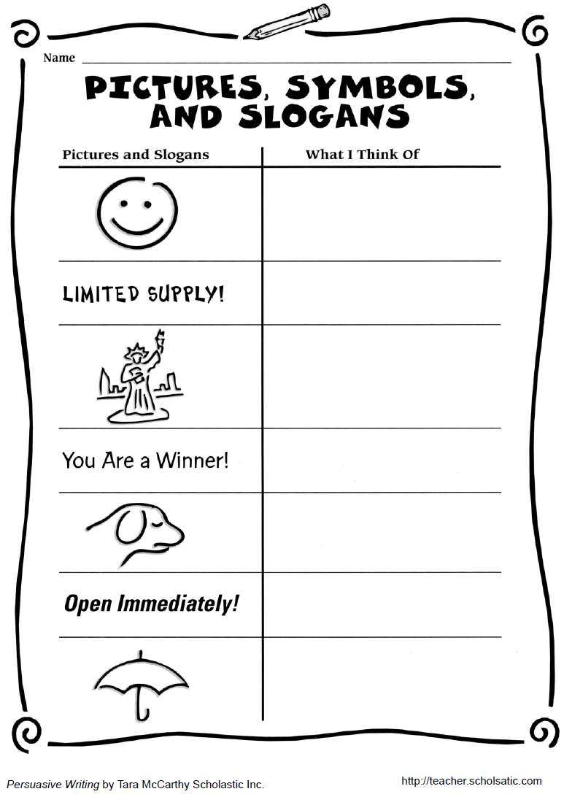**

**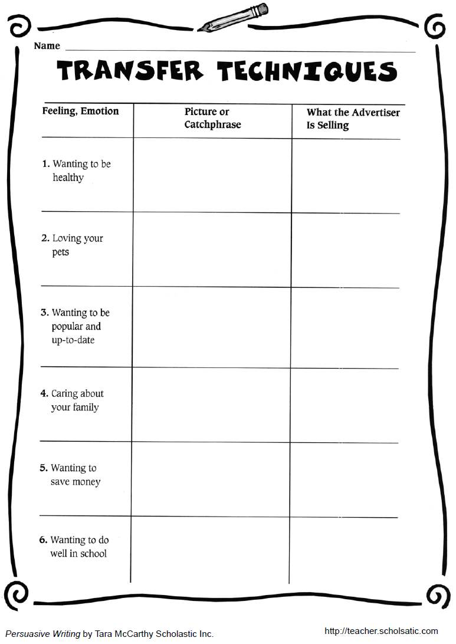**

**Voice-Over Rubric**

|  |  |  |  |
| --- | --- | --- | --- |
|  | **4**  **SUPERIOR** | **3**  **SUCCESSFUL** | **2**  **SUFFICIENT** |
| **Name of**  **Product or Service** | Of high interest and high appeal to target audience | Appealing to target audience | Appealing but of low interest to target audience |
| **Slogan, Motto**  **or Catch-phrase** | Striking, catchy, memorable and persuasive to target audience | Easily remembered and appropriate to audience | Appropriate to audience |
| **Details** | Uses clearly stated, thoughtfully chosen, powerful points to win over target audience | Uses well-chosen details to persuade target audience | Uses some details to sway target audience |
| **Word Choice** | Uses imagery to successfully make strong, persuasive appeals to emotion | Uses imagery successfully to make appeals to emotion | Uses imagery to appeal to emotion |
| **Volume, Pace, & Vocal Inflection** | Vocals are clear and convincing, and important points are well communicated | Vocals are clear and important points are emphasized | Vocals are audible and important points are emphasized |
| **Target Audience** | Creatively, consistently and clearly focused on target audience | Clearly focused on Target Audience | Aimed at a Target Audience |

**Persuasive Presentation Rubric**

|  |  |  |  |
| --- | --- | --- | --- |
| *Qualities* | ✔  *Check this column*  *if presentation*  *quality reflects a*  **SUPER JOB** | ✔  *Check this column*  *if presentation*  *quality reflects a*  **GOOD JOB** | ✔  *Check this column*  *if presentation quality*  **COULD BE BETTER** |
| **Volume**  (clear and convincing) |  |  |  |
| **Pacing**  (clear and convincing) |  |  |  |
| **Vocal Inflection**  (clear and convincing) |  |  |  |
| **Word Choice**  (appeals to emotion) |  |  |  |
| **Music & Pictures**  (appeals to emotion) |  |  |  |
| **Target Audience**  (tailored to the interests of intended listeners) |  |  |  |

**POP: Pathos**  
Pre-Test Questions, Data for web POP Quiz I – Diagnostic



**Directions: Word Matching Test**

Match the word to the definition that best fits

slogan

imagery

rhetoric

* a short and striking or memorable phrase used in advertising
* visually descriptive or figurative language
* the language used in powerful and persuasive speaking or writing
* a group of people who research and create advertisements
* a group identified by some common characteristic, interest, or need
* the appeal to emotions and feelings through pictures or phrases

**Directions: Multiple-Choice Test**

**Read each question and record your answer**

1. Which of these are you thinking about when you make sure that what you say interests the specific people who are listening?

a. audience

b. purpose

c. pronunciation

d. word choice

2. Which of these should a speaker practice in order to stay within a time limit and let the audience understand the words that are said?

a. pacing or speed

b. pronunciation

c. vocal inflection

d. volume

3. Which of these characteristics involves using vivid image words, repetition, or figurative language to hold the attention of the audience?

a. audience

b. organization

c. purpose

d. word choice

4. When you make sure to include an introduction, a main idea with details, and a conclusion, which of these are you paying attention to?

a. vocal inflection

b. organization

c. purpose

d. word choice

5. Which of these helps you to hold the audience’s attention, emphasize key points, and add voice interest as you give your speech?

a. purpose

b. vocal inflection

c. diction

d. organization

6. All of the following ‘good speaker’ characteristics are necessary in an oral presentation. One of them, however, makes sure that the audience will hear the speech. It is . . .

a. pacing

b. pronunciation

c. purpose

d. volume

**Bonus Question!**

Name the three types of appeals identified by Aristotle in classical rhetoric.

**POP: Pathos**  
Test Questions, Data for Web POP Quiz II – Summative



**Directions: Word Matching Test**

Match the word to the definition that best fits

target audience

rhetoric

transfer

* a short and striking or memorable phrase used in advertising
* visually descriptive or figurative language
* the language used in powerful and persuasive speaking or writing
* a group of people who research and create advertisements
* a group identified by some common characteristic, interest, or need
* the appeal to emotions and feelings through pictures or phrases

**Directions: Multiple-Choice Test**

**Read each question and record your answer**

1. Which of these must you think about as you create a meaningful speech for the audience?

a. pacing

b. purpose

c. volume

d. diction

2. Which of these helps you to hold the audience’s attention, emphasize key points, and add voice interest as you give your speech?

a. purpose

b. vocal inflection

c. diction

d. organization

3. When you make sure to include an introduction, a main idea with details, and a conclusion, which of these are you paying attention to?

a. vocal inflection

b. organization

c. purpose

d. word choice

4. Which of these characteristics involves using vivid image words, repetition, or figurative language to hold the attention of the audience?

a. audience

b. organization

c. purpose

d. word choice

**Directions for the Writing Prompt:**

Describe in detail what it takes to make a good speaker. Remember to introduce your points, support them with details, and sum it all up with a conclusion. Try to meet or exceed our class goal of at least three paragraphs.

Consider highlighting these points:

Targeting your audience and purpose

Volume, Pacing and Vocal inflection

Word choice



**Vocabulary Quiz Bowl Items**

* logos
* pathos
* ethos
* volume
* pacing
* vocal inflection
* rhetoric
* imagery
* persuasive
* transfer
* voice-over
* pronunciation
* target audience
* figurative language
* symbol
* catch-phrase
* slogan
* motto
* advert