“Never be afraid to sit awhile and think.”
– Lorraine Hansberry
Words Have Power

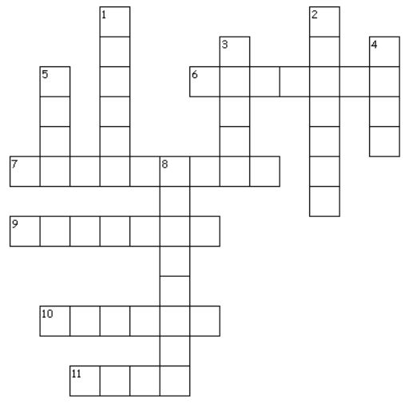
Across
6. Lorraine Hansberry's hometown
7. who is in the story
9. where a story’s action takes place
10. child's name in A Raisin in the Sun
11. what the basic situation of a story is

Down
1. brother's name in A Raisin in the Sun
2. same element at both the beginning and end of a text
3. how a story is shaped and given meaning
4. how a text makes readers feel
5. wife's name in A Raisin in the Sun
8. why there is opposition in a story

