Literary Terms

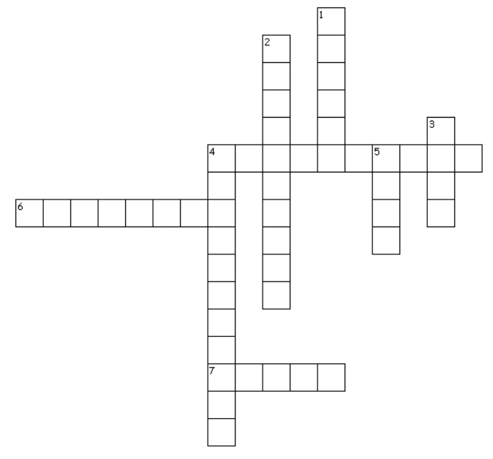
Across
4. sight, sense, or awareness
6. a description by comparison NOT using "like" or "as"
7. an expression particular to a certain person or group

Down
1. a description by comparison using the words like or as
2. any written text
3. the atmosphere and feeling of a story
4. point of view (P.O.V.)
5. author’s attitude toward subject or characters

